1. President – Shri S R Vishwanath

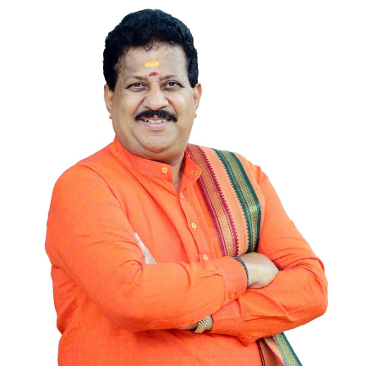 About – MLA, Yelahanka | Member, TTD Board | Former Chairman, Bangalore Development Authority (BDA)

1. Vice-president – R M Somashekar Reddy

About -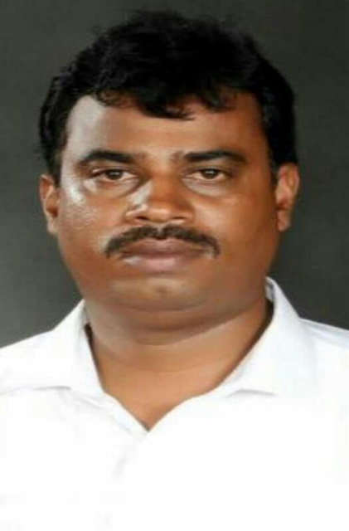 Businessman

1. Treasurer – RC Rajendra Kumar

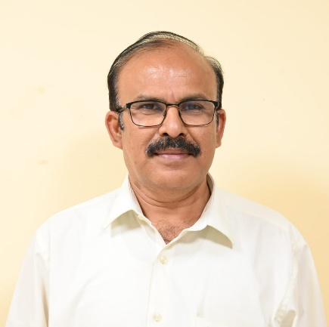

About - B.Pharm, Social Worker.